2021 – YR 10 EXTENSION – BIOLOGICAL SCIENCES EXAM REVISION

BOOKLET 1
YEAR 10 SEMESTER ONE EXAM 2021
BIOLOGICAL SCIENCES – EXTENSION

FULL NAME:
TEACHER:
SUGGESTED TIME: 1 Hour 20 minutes
SECTION A – MULTIPLE CHOICE QUESTIONS – Total: 30 MARKS
Use pencil to shade the letter that matches the most correct answer on the Multiple Choice sheet provided. Erase incorrect answers completely.
SECTION B – SHORT ANSWER QUESTIONS – Total: 50 MARKS
Please answer these questions in pen on the lined spaces provided in this booklet.
SECTION C – EXTENDED ANSWERS – Total: 20 MARKS
Please answer this question in pen on the lined pages towards the end of the booklet.
SECTION A | /30
SECTION B | /50
SECTION C | /20
TOTAL: BIOLOGICAL SCIENCES | /100

Complete the following worksheets: Answers have been placed on SEQTA
Complete: GENETICS GLOSSARY
DNA
gene
allele
chromosome
diploid
haploid
interphase
Replication

centriole
centrosome
centromere
chromatid
homologous chromosomes
Autosomal trait
mitosis
meiosis
2n
n
crossing over

karyotype
karyokinesis
sex chromosomes
Cytokinesis
nucleotide
interphase
template
complement
Incomplete dominance
Co dominance
species
mutant
mutagen
mutation
epigenetics
evolution
heterozygous (hybrid)
Homozygous (true breeding)
Explain, using diagrams, all the phases that a cell that is dividing by the process of mitosis will go through in its cell cycle. Chromosome number 2n = 4

DIAGRAM | EXPLANATION
INTERPHASE

MITOSIS - PROPHASE

METAPHASE

ANAPHASE

TELOPHASE

- When will a cell undergo meiotic cell division?
______________________________________________________________________________________________________________________________________________

- List 5 ways in which meiosis differs from mitosis.

MITOSIS | MEIOSIS

- What does DNA stand for?

___________________________________________________

- Sketch a labeled diagram of DNA molecule. (Use pencil)

- Why does a cell need to replicate its DNA?

____________________________________________________________________

- During which phase of a cell’s life cycle will a cell replicate its DNA?

___________________________________________________

8.. Outline, stating examples, the difference between autosomal inheritance, codominant inheritance, incompletely dominant inheritance and X-linked inheritance.
Autosomal: ___________________________________________________________
_____________________________________________________ __________________
Codominant inheritance ___________________________________________________
_______________________________________________________________________
Incomplete dominance ____________________________________________________
_______________________________________________________________________
Sex-linked or X-linked inheritance ____________________________________________
_______________________________________________________________________

9. Use a Punnett square to explain what happens when red and white flowers are crossed during codominance.

- . Use a Punnett square to explain what happens when red and white flowers are crossed during incomplete dominance.

11. Determine the possible genotypes and phenotypes of the offspring if two heterozygous bronze turkeys are crossed, given that in turkeys bronze colour is dominant to red colour.

12. In fowls, red plumage is recessive to black plumage. Determine the possible offspring genotypes and phenotypes if a heterozygous black fowl is crossed with a red fowl.

13. In cattle, those with horns are recessive to no-horned cattle. What are the probabilities of offspring genotypes and phenotypes if a homozygous recessive horned bull is crossed with a heterozygous no-horned cow?

14. Determine the possible genotypes and phenotypes of the offspring if two heterozygous red tomatoes are crossed, given that in tomatoes red coloured fruit is dominant to yellow coloured fruit.

15. In guinea pigs, a homozygous dominant yellow crossed with a homozygous white produce cream coloured offspring. Determine the possible genotypes and phenotypes of the offspring if a cream coloured guinea pig is crossed with a yellow coloured.

Dominance type:

16. In pigs, a homozygous black crossed with a homozygous white produce black-and-white coloured piglets. Determine the possible genotypes and phenotypes of the offspring if a black-and-white pig is crossed with a black coloured pig.
Dominance type:

17. In four-o'clock plants, if a homozygous red flowered plant is crossed with a homozygous white flowered plant, the offspring have pink flowers. Determine the genotypes and phenotypes of the offspring if a pink flowered four-o'clock plants is crossed with a red flowered plant.

Dominance type:

18. In short-horned cattle, a homozygous red crossed with a homozygous white produce "roan" offspring. Determine the possible genotypes and phenotypes of the offspring if a pure-breeding, red coated short-horned bull is crossed with a roan coated, shorthorn cow.

Dominance type:

19. In humans muscular dystrophy is a sex-linked disease which is recessive. Determine the possible genotypes and phenotypes of the offspring if a normal man marries a woman who suffers from the disease.

20. In humans muscular dystrophy is a sex-linked disease which is recessive. Determine the possible genotypes and phenotypes of the offspring if a normal man marries a woman carrier.

21. In humans colour blindness is a sex-linked disease which is recessive. Determine the possible genotypes and phenotypes of the offspring if a normal man produces children with a colour blind woman.

Question 22 refer to the diagrams below

A 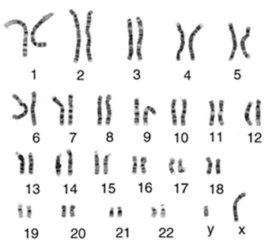 | B 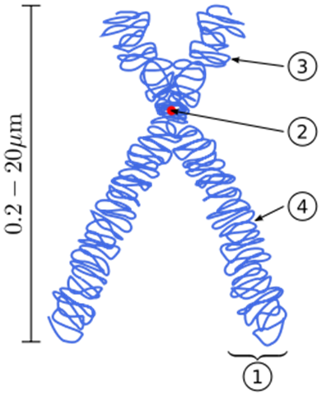
C 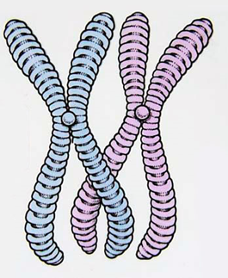 | D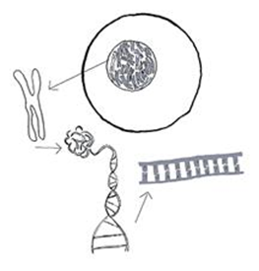

23.
- Which of the images shows a homologous pair of chromosomes? ______________
- Which of the images shows a karyotype? _________________________________
- In a root cell of a pea plant there are 14 chromosomes. How many chromosomes would there be in the nucleus of a pollen grain of a pea plant? _________________
- What causes most of the variation between individuals of the same species?
__________________________________________________________________
__________________________________________________________________
24. Use the following information to answer questions (a) to (h).
The gene for long eyelashes is dominant to the gene for short eyelashes. A man who is heterozygous for eyelash length marries a woman who is also heterozygous for eyelash length.
- What is the woman’s genotype? _________________________________________
- What is the probability that their child will have long eyelashes? Show working.

- The couple has two children with short eyelashes. What is the probability that their third child will also have short eyelashes?

___________________________________________________________________
- Who determines the gender of a child? Explain with reasons.
___________________________________________________________________
___________________________________________________________________

- If a person has two identical genes for a particular trait, what are the genes referred to as?
__________________________________________________________________
- What is the main difference between autosomal and sex chromosomes?
__________________________________________________________________
__________________________________________________________________
- Name the smallest piece of genetic material which has the instructions for one
characteristic, like wide nostrils. ________________________________________
- What causes differences between identical twins? __________________________
- What is a mutation?
____________________________________________________________________
____________________________________________________________________

- What is a mutagen?____________________________________________________
____________________________________________________________________
Give examples of mutagens _____________________________________________

- Explain the difference between a mutation and epigenetics.
______________________________________________________________________________________________________________________________________________________________________________________________________________________________________________________________________________
- Define Evolution
____________________________________________________________________________________________________________________________________________________________________________________________________________
- Give definitions for a gene, genepool, an allele and a chromosome showing the differences between these 3 terms.
Gene : _____________________________________________________________
____________________________________________________________________
Allele : _____________________________________________________________
____________________________________________________________________
Chromosome__________________________________________________________
____________________________________________________________________
Genepool: ___________________________________________________________
____________________________________________________________________
- Name and explain five mechanisms that can contribute to the process of evolution.

- ____________________________________________________________________________________________________________________________________________________________________________________________________________________________________________________________________________________________________________________________________________________

- ____________________________________________________________________________________________________________________________________________________________________________________________________________________________________________________________________________________________________________________________________________________

- ____________________________________________________________________________________________________________________________________________________________________________________________________________________________________________________________________________________________________________________________________________________

- ___________________________________________________________________________________________________________________________________________________________________________________________________________________________________________________________________________________________________________________________________________________
- ___________________________________________________________________________________________________________________________________________________________________________________________________________________________________________________________________________________________________________________________________________________

- Explain how the process of natural selection can contribute to a bacterium becoming resistant to antibiotics.
__________________________________________________________________________________________________________________________________________________________________________________________________________________________________________________________________________________________________________________________________________________________________________________________________________________________________________________________________________________________________________________________________________________________________________________________________________________________________________________________________________________________________________________________________________________________________________________________________________________________________________________________________________________________________________________________________________________________________________________________________
- Explain the steps in speciation.
______________________________________________________________________________________________________________________________________________________________________________________________________________________________________________________________________________________________________________________________________________________________________________________________________________________________________________________________________________________________________________________________________________________________________________________________________________________________________________________________________________________________________________________________________________________________________________________________________________________________________________________________________________________________________________________________________________________________________________________________________________________________________________________________________________________________________________________________________________________
________________________________________________________________________________________________________________________________________________________________________________________________________________________________________________________________________________________________________________________________________________________________________________________________________________________________________________________________________________________________________________________________________________________________________________________________________________________________________________________________________________________________________________________________________________________________________________________________________________________________________________________________________________________________________________________________________________________________________________________________________________________________________________________________________________________________________________________________________________________________________________________________________________________________________________________________________________________________________________________________________________________________________________________________________________________________________________________________________________________________________________________________________________________________________________________________________________________________________________________________________________________________________________________________________________________________________________________________________________________________________________________________________________________________________________________________________________________________________________________________________________________________________________________________________________________________________________________________________________________________________________________________________________________________________________________________________________________________________________________________________________________________________________________________________________________________________________________________

